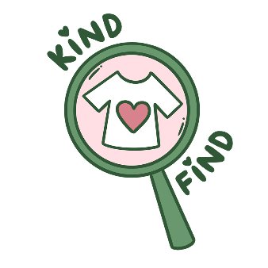

KindFind Privacy Policy

Thank you for using KindFind!
Our mission is to make charity shopping easier, and to do that we require certain permissions from your phone to access data about you. We wrote this policy to help you understand what these permissions do and what the information is used for.
We process any information in accordance with GDPR principles, and you as the user can request that any information about you (account information, photos uploaded) is deleted from our database.

When you use KindFind, you voluntarily share certain information
- Account Information: When you join KindFind we collect information such as your email address and display name. If you have a store account we also collect which store you are, and the location of the store.
- Content: We collect information when you upload posts, such as the photo uploaded and the information entered about the post
- Precise location information: To use our map feature and upload an image to a store, we require your location via your device settings. We do not store this information specific to any user.
- Your communication with us: If you contact us for support or other communication, we collect the content of the communications for future records.

How we use the information we collect
We want to show content that’s relevant and interesting to you. To do that, we use information you provide to improve your experience, including:
- Use collected information about which charity shops are the most popular, to target more adverts for businesses and events happening in that area.

How information is shared
Anyone can see posts you upload; therefore any information held in these posts are available to other users within the application.

How long we keep your information for
We keep your information only as long as we need it to fulfil the purposes described in this policy. When we no longer need the information and there is no need for us to comply with legal requirements, we will remove it from our database. As a user you also have the right to have any information held about you removed from our database as any time, or have any information held about you disclosed.

Other permissions required by KindFind
- Notifications: We use this to tell you important information regarding the app, including whether your reserved item is ready to be picked up or reminders of how long is left to pick up an item. If you are a store account, notifications are used to alert to when and which items have been reserved.

How changes are made to this policy
We might change this policy to be up to date with the features within the application, if any changes are made, they will be updated here. If you continue to use KindFind after the changes are implemented, the updated policy will apply. If the changes are significant, we may provide a more prominent notice, such as by email.

Contact us
If you have any questions or concerns the best way to get in touch with us is through our website (INSERT WEBSITE).

